Video Interviews with Elders

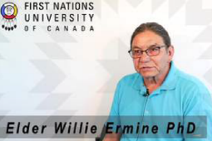
Elder Willie Ermine, PhD:
A Culture of Sharing
https://urcourses-video.uregina.ca/index.php/extwidget/preview/partner_id/106/uiconf_id/23448627/entry_id/0_gqkz7r3j/embed/auto?&flashvars[streamerType]=auto
“Counter-narrative: The importance of the giveaway” (3:32)
https://urcourses-video.uregina.ca/index.php/extwidget/preview/partner_id/106/uiconf_id/23448627/entry_id/0_vm0fd5zq/embed/auto?&flashvars[streamerType]=auto
“Giving what you treasure to get what you need” (1:02)
https://urcourses-video.uregina.ca/index.php/extwidget/preview/partner_id/106/uiconf_id/23448627/entry_id/0_cicdrgjo/embed/auto?&flashvars[streamerType]=auto
“Indigenous values: The stigma of hoarding” (1:03)
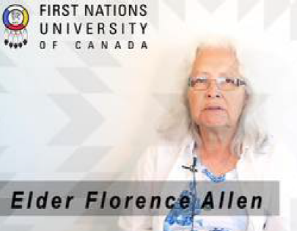
https://urcourses-video.uregina.ca/index.php/extwidget/preview/partner_id/106/uiconf_id/23448627/entry_id/0_9z845n47/embed/auto?&flashvars[streamerType]=auto

ELDER FLORENCE ALLEN:
“Planning for the unexpected” (4:08)
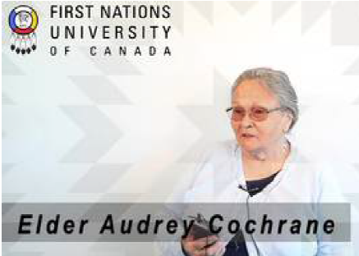
https://urcourses-video.uregina.ca/index.php/extwidget/preview/partner_id/106/uiconf_id/23448627/entry_id/0_y3vpjiej/embed/auto?&flashvars[streamerType]=auto

ELDER AUDREY COCHRANE:
“Raising grandchildren and the ways of living on the land” (2:26)
https://urcourses-video.uregina.ca/index.php/extwidget/preview/partner_id/106/uiconf_id/23448627/entry_id/0_f0krtktu/embed/auto?&flashvars[streamerType]=auto

“The importance of sharing with community” (0:46)
https://urcourses-video.uregina.ca/index.php/extwidget/preview/partner_id/106/uiconf_id/23448627/entry_id/0_qfkiyt2o/embed/auto?&flashvars[streamerType]=auto

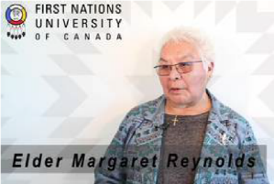
ELDER MARGARET REYNOLDS:
“Financial self-sufficiency through self-employment” (1:49)
https://urcourses-video.uregina.ca/index.php/extwidget/preview/partner_id/106/uiconf_id/23448627/entry_id/0_8q4cevo8/embed/auto?&flashvars[streamerType]=auto
“Reusing and saving” (1:45)
https://urcourses-video.uregina.ca/index.php/extwidget/preview/partner_id/106/uiconf_id/23448627/entry_id/0_czox7aro/embed/auto?&flashvars[streamerType]=auto
“The value of money” (0:27)
https://urcourses-video.uregina.ca/index.php/extwidget/preview/partner_id/106/uiconf_id/23448627/entry_id/0_0xunrbtf/embed/auto?&flashvars[streamerType]=auto

“Money management and sharing” (1:10)
https://urcourses-video.uregina.ca/index.php/extwidget/preview/partner_id/106/uiconf_id/23448627/entry_id/0_1f10of95/embed/auto?&flashvars[streamerType]=auto

“The value of giving money to family in need” (0:48)
https://urcourses-video.uregina.ca/index.php/extwidget/preview/partner_id/106/uiconf_id/23448627/entry_id/0_3h6ds6r8/embed/auto?&flashvars[streamerType]=auto

“Money as a sickness” (1:17)
https://urcourses-video.uregina.ca/index.php/extwidget/preview/partner_id/106/uiconf_id/23448627/entry_id/0_c1pnxmtx/embed/auto?&flashvars[streamerType]=auto

“The role of mutual and trust funds in caring for grandchildren” (0:36)
https://urcourses-video.uregina.ca/index.php/extwidget/preview/partner_id/106/uiconf_id/23448627/entry_id/0_4w5i93tm/embed/auto?&flashvars[streamerType]=auto
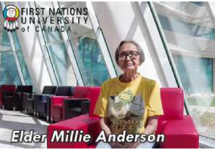

ELDER MILLIE ANDERSON:
“Learning how to manage money” (1:38)
https://urcourses-video.uregina.ca/index.php/extwidget/preview/partner_id/106/uiconf_id/23448627/entry_id/0_918k15cr/embed/auto?&flashvars[streamerType]=auto

“Savings” (1:06)
https://urcourses-video.uregina.ca/index.php/extwidget/preview/partner_id/106/uiconf_id/23448627/entry_id/0_c3wf32e9/embed/auto?&flashvars[streamerType]=auto

